OpenSIS information requirement for implementation

- School Information Setup
  - Name of the Institution
  - Address
  - Telephone
  - Dean, Headmaster or Principal
  - Default Grade Scale i.e. 4.00
  - e-Mail
  - Web Site
- Calendar and Marking Periods
  - First and last day of the school year i.e. June 30th to July 1st
  - Recognized Holidays and Vacations i.e. http://www.icalworld.com/holidays.html
  - Semester, Quarter, Progress Period dates with grade posting periods
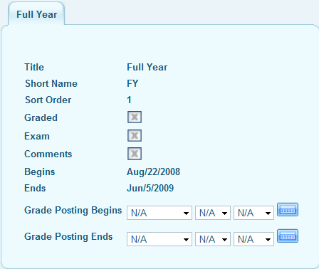

- Attendance codes (e.g.: Present, Absent, Tardy, Excused Absence etc)
- Completed “Student Information Checklist”
- Spreadsheet of Historical student data required i.e. Year of course taken, course name, location, grade , credit
- Course Catalog
  - Subject
  - Course name
  - Course period setup…see screen shot below for field information needed.
*Using consistent short names \ abbreviations that indicate subject, course and period make the report cards easier to understand.

